The Chinook data model (below) represents a digital media store, including tables for artists, albums, media tracks, invoices and customers. Chinook data model is an ER Model.

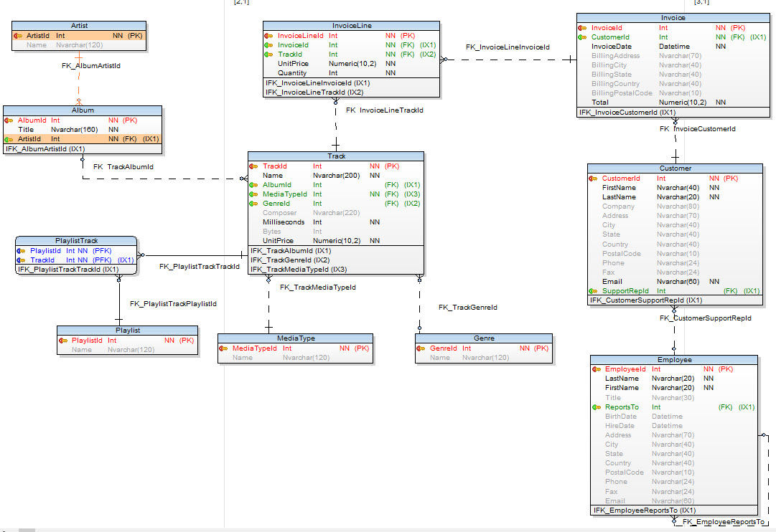

Figure 1: Chinook - System of record (SOR)

|  |  |  |
| --- | --- | --- |
| dbName | TableName | Table_Rows |
| chinook | Album | 347 |
| chinook | Artist | 275 |
| chinook | Customer | 59 |
| chinook | Employee | 8 |
| chinook | Genre | 25 |
| chinook | Invoice | 412 |
| chinook | InvoiceLine | 2,240 |
| chinook | MediaType | 5 |
| chinook | Playlist | 18 |
| chinook | PlaylistTrack | 8,715 |
| chinook | Track | 3,503 |

Figure 2: Chinook SOR - Tables with row counts

# Deliverables:

* Convert ER Model to Dimensional Model
  + **List fact(s) & dimensions**

Fact_Track, Fact_Invoice, Dim_Album, Dim_Genre, Dim_MediaType, Dim_Artist, Dim_Playlist, Dim_InvoiceLine, Dim_Date, Dim_Customer, Dim_Employee, Dim_Geography

* + **What tables will be combined?**

The above tables are connected

* + **Create date/calendar dimension**

Created

* + **Create tables with surrogate SKs, NKs & FKs**

Created

* + **Create geography table**

Created

* + **Map source table(s) to target table**

Mapped

* Create data model in ER/Studio
* Create DDL & create tables in:
  + SQL Server
  + MySQL
  + PostgreSQL
  + Oracle 11gR2